**Registration for “CloudUp for Her” Cloud Practitioner**

To avail 50% discount voucher for AWS cloud practitioner through skill builder:

1. Visit <https://pages.awscloud.com/cloudup-for-her-cloud-practitioner.html> and fill in the details in the mentioned fields .

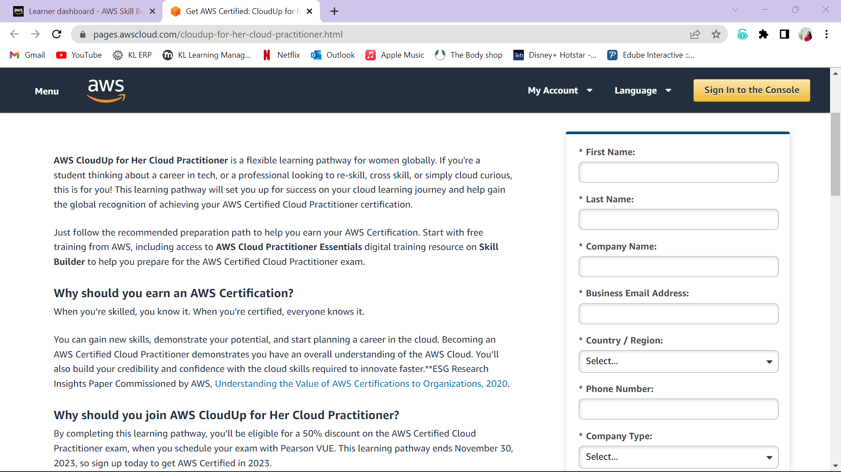

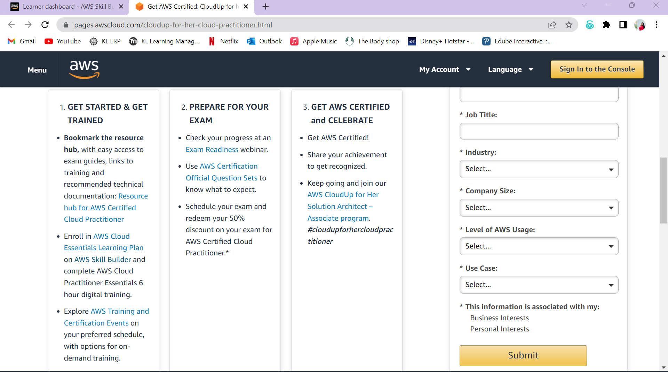

1. **NOTE:**

* Use a **new email id** and **new phone number** which are not associated with any of the existing AWS skill builder account.
* After you complete the AWS CloudUp for Her Cloud Practitioner, you will receive email instructions on how to utilize your voucher and schedule your exam.
* You have until November 30, 2023 to join and access your exam voucher. Your exam appointment can be for any day before December 31, 2023.

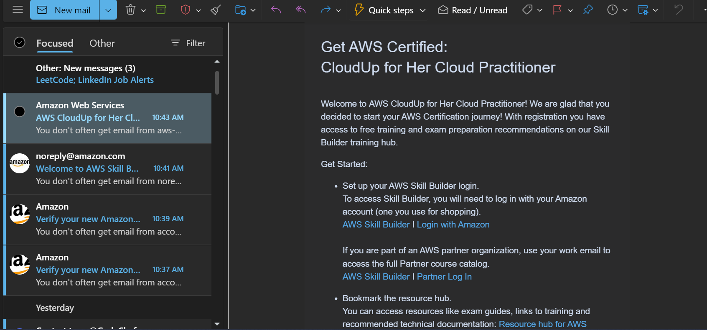

1. Visit <https://skillbuilder.aws/>

|  |
| --- |
|  |
| **Get Started:**   * **Set up your AWS Skill Builder login**. To access Skill Builder, you will need to log in with your Amazon account (one you use for shopping). [AWS Skill Builder](https://vmxwvcrs.r.us-east-1.awstrack.me/L0/https:%2F%2Femail.awscloud.com%2FMTEyLVRaTS03NjYAAAGMhaRQXTbVDxbuZzi-T5fRvyCq8DhuDCjiQPaxTbCkgKqdNBLVCl3Kq_IhQT-rta_45yUWtVM=/1/01000188e6aba97b-eb964d88-0ba5-4da1-830c-4bc7f5041087-000000/X95bw7u6BxxkoNsNxRsN7w3t3t0=327) I [Login with Amazon](https://vmxwvcrs.r.us-east-1.awstrack.me/L0/https:%2F%2Femail.awscloud.com%2FMTEyLVRaTS03NjYAAAGMhaRQXZOIZxq2T5jSNcl1MrjO73RycpNFETis3-vn_YxiZjpGUPw5QXZeRUse_MEQr5wJaFc=/1/01000188e6aba97b-eb964d88-0ba5-4da1-830c-4bc7f5041087-000000/9z2eTDXpjtJ9KRkLq8ZhKUVbHbs=327)  If you are part of an AWS partner organization, use your work email to access the full Partner course catalog. [AWS Skill Builder](https://vmxwvcrs.r.us-east-1.awstrack.me/L0/https:%2F%2Femail.awscloud.com%2FMTEyLVRaTS03NjYAAAGMhaRQXTbVDxbuZzi-T5fRvyCq8DhuDCjiQPaxTbCkgKqdNBLVCl3Kq_IhQT-rta_45yUWtVM=/2/01000188e6aba97b-eb964d88-0ba5-4da1-830c-4bc7f5041087-000000/XmGY42UaQ9zVqPkpumdm2zsjJh0=327) I [Partner Log In](https://vmxwvcrs.r.us-east-1.awstrack.me/L0/https:%2F%2Femail.awscloud.com%2FMTEyLVRaTS03NjYAAAGMhaRQXgXHrZwLiyNy_HDyI-aoBc0q1L0EZkvkFnx90eh_xUrO3TwoBA7trUO2Oa51NIrUhwg=/1/01000188e6aba97b-eb964d88-0ba5-4da1-830c-4bc7f5041087-000000/dhp0x02pafWAC9SEPeid_es1abo=327) * **Bookmark the resource hub.** You can access resources like exam guides, links to training and recommended technical documentation: [Resource hub for AWS Certified Cloud Practitioner](https://vmxwvcrs.r.us-east-1.awstrack.me/L0/https:%2F%2Femail.awscloud.com%2FMTEyLVRaTS03NjYAAAGMhaRQXjkx1rNIB5PpAfPoS3vRsksieNQDqLAw5OTjLp5Ox7lOU-Qab_u5t9yT_NU9_67lMzU=/1/01000188e6aba97b-eb964d88-0ba5-4da1-830c-4bc7f5041087-000000/u9CYTH8XH3id30wzzfxuZQvP8Ps=327) |

1. Create an AWS account with the previously entered mail-id and phone number and sign up into the AWS skill builder.

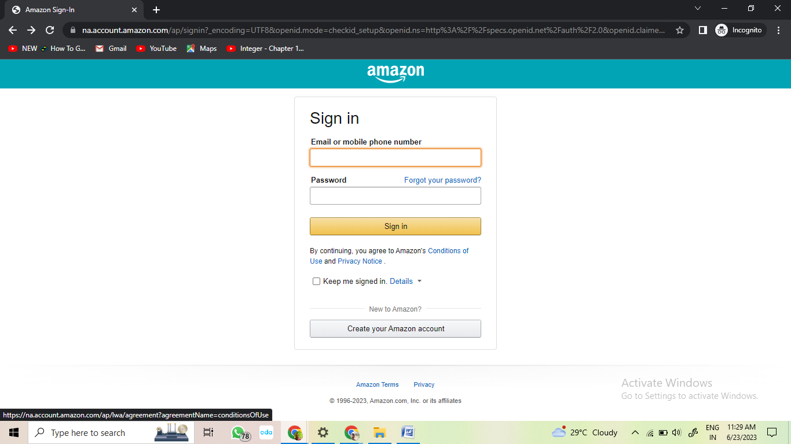

**NOTE:** Do not use the mail-id and phone number already associated with your existing AWS Skill Builder account.

1. After signing up, sign-in into the AWS skill builder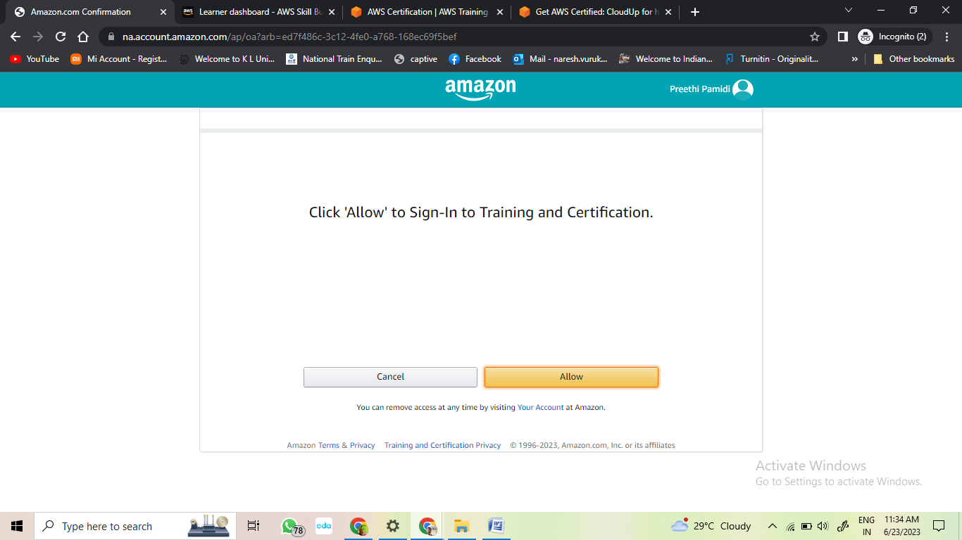
2. **Complete your training and get exam ready**.  
   Start by completing [AWS Cloud Practitioner Essentials](https://vmxwvcrs.r.us-east-1.awstrack.me/L0/https:%2F%2Femail.awscloud.com%2FMTEyLVRaTS03NjYAAAGMhaRQXciuEK6wGnz3qJSKOD0pmj4UYAr9vOS9o-cXVVOeQny-4NO5OeMimatQ0krZlrkI0N0=/1/01000188e6aba97b-eb964d88-0ba5-4da1-830c-4bc7f5041087-000000/z5EQ75sFD42jM3ArOH83xINdAp0=327), a free 6 hour digital training course.

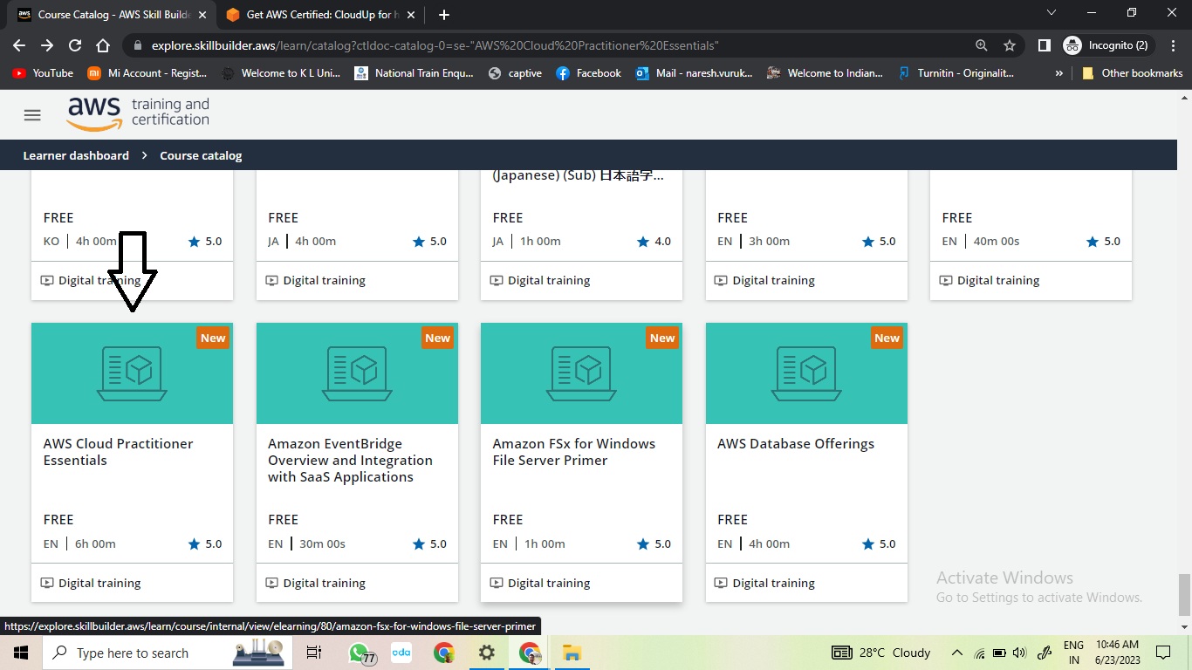

1. **To request your 50% exam voucher, email following to**[awscloudupcpe@amazon.com](https://vmxwvcrs.r.us-east-1.awstrack.me/L0/https:%2F%2Femail.awscloud.com%2FMTEyLVRaTS03NjYAAAGMhaRQXYTopD208TpdFxzXinDBshM53LRYSNK5gV44ljDajSc5VR10UYDnN_Ot_IVKBUqDvlM=/1/01000188e6aba97b-eb964d88-0ba5-4da1-830c-4bc7f5041087-000000/WKqLb7g_-8maBbvqHMWh7C9cNAE=327)

**Your Name (First and Last Name):   
Country of Residence:  
Link to your LinkedIn Profile (Or a copy of ID with name and photo visible):  
Screen shot of a practice test with a score of 80% or more:**

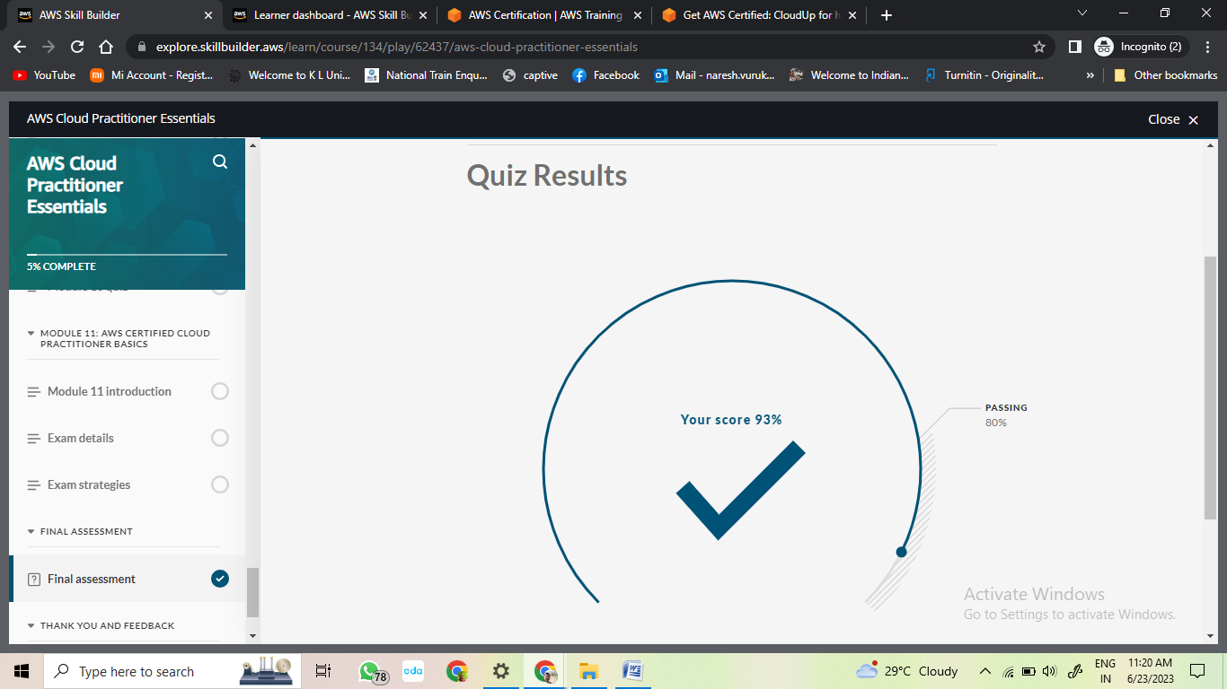

* After requesting for the voucher, you need to wait for 5-10 business days (After verifying your details you will be receiving a voucher through [**support@xvoucher.com**](mailto:support@xvoucher.com)).
* **NOTE:** If you have less than 200 connections in the LinkedIn, it is recommended to use a picture of your college ID as proof.

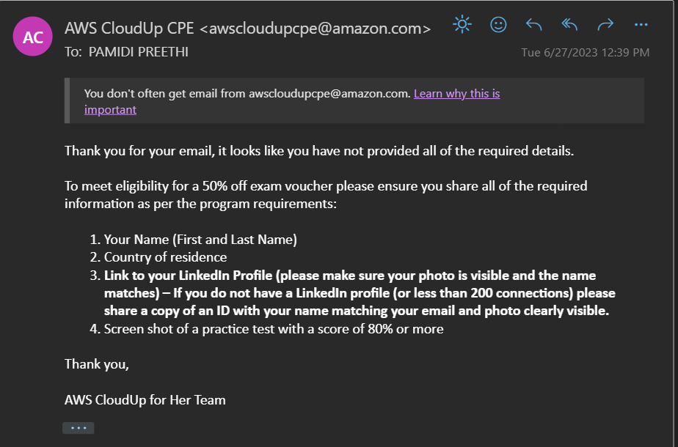

1. After submitting the proper details, you’d receive a mail from [support@xvoucher.com](mailto:support@xvoucher.com) and you can avail 50% discount from this voucher code.

